

CREATING AN INGRESS
DevOps Certification Training

support@intellipaat.com
+91-7022374614
US: 1-800-216-8930(Toll Free)

CREATING AN INGRESS
Steps for Master

Step 1: We will first have to install an ingress controller ‘nginx’. Execute the following command:
$ kubectl apply -f https://raw.githubusercontent.com/kubernetes/ingress-nginx/master/deploy/mandatory.yaml

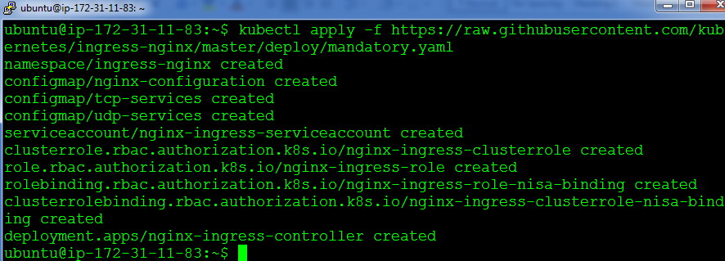

Step 2: Next install a service for this ingress controller, using this command:
kubectl apply -f https://raw.githubusercontent.com/kubernetes/ingress-nginx/master/deploy/provider/baremetal/service-nodeport.yaml

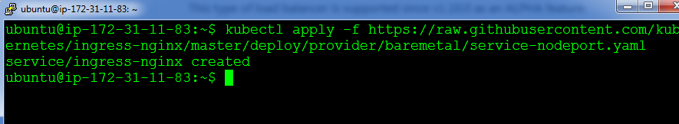

Step 3: Next, since ingress routes to only cluster-ip services, let us delete our previously created nginx nodeport service and create a service with clusterip for nginx. Use the following commands:
$ kubectl delete service nginx
$ kubectl create service clusterip nginx –tcp=80:80

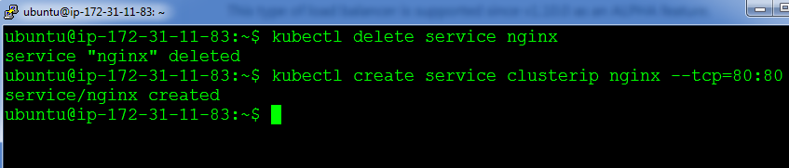

Step 4: Next, we will have to create an ingress rule, create an ingress.yaml file with the below code:
apiVersion: extensions/v1beta1
kind: Ingress
metadata:
name: simple-fanout-example
annotations:
nginx.ingress.kubernetes.io/rewrite-target: /
spec:
rules:
- http:
paths:
- path: /nginx
backend:
serviceName: nginx
servicePort: 80

Step 5: Finally, create the ingress rule using the following command:
$ kubectl create –f ingress.yaml

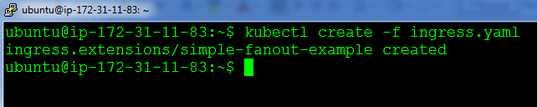

Step 6: Let’s verify if ingress is working or not, by checking the nodeport of the ingress service, for checking the nodeport use the following command:
$ kubectl get svc –n ingress-nginx

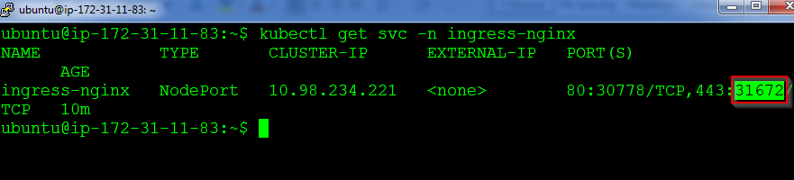

Step 7: Finally verify by browing to https://<IP-address-of-master or slave>:<nodeport>/nginx
